Promotion Materials aremetin içeren bir resim

Açıklama otomatik olarak oluşturuldumetin, kitap, Broşür, katalog içeren bir resim

Açıklama otomatik olarak oluşturuldumetin, yayımlama, neşir, neşriyat, kitap, kağıt içeren bir resim

Açıklama otomatik olarak oluşturuldu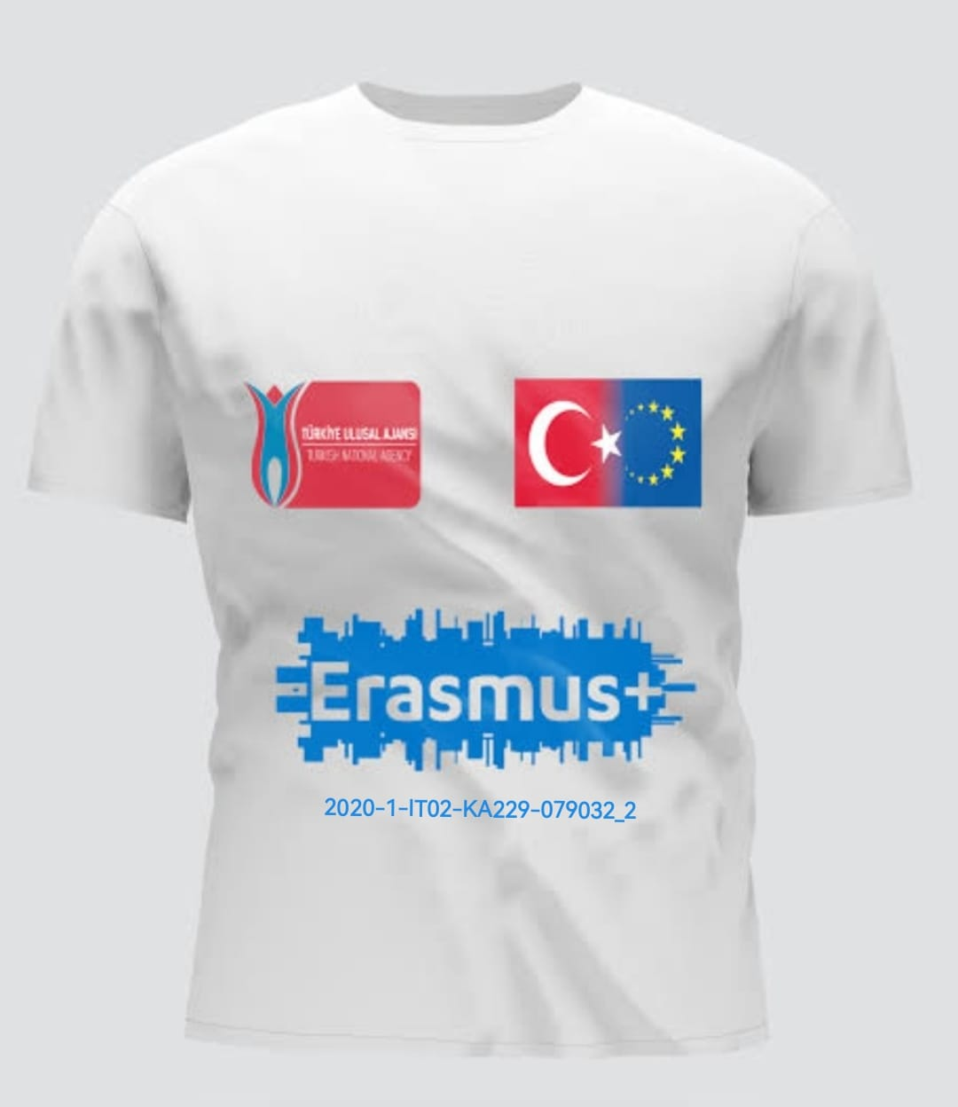kupa, kahve fincanı, bardak takımı, sofra takımı içeren bir resim

Açıklama otomatik olarak oluşturuldu

Our Instagram Account

<https://www.instagram.com/enact.tr/>

Facebook Account

<https://www.facebook.com/groups/1244135982628907>

News on School website

<https://sinaniummiimamhatipoo.meb.k12.tr/icerikler/sinan-i-ummi-imam-hatip-ortaokulumuzun-2020-1-it02-ka229-079032-6-numarali-ve-exploring-natural-and-cultural-treasures-in-europe-baslikli-projesi-2834200-euro-hibe-destegi-almaya-hak-kazandi_11395790.html>

Local newspaper

<https://www.facebook.com/plugins/post.php?href=https%3A%2F%2Fwww.facebook.com%2FElmaliGundem%2Fposts%2F2187529218055336>

National Newspapers

1. <https://www.sondakika.com/amp/haber-elmali-da-ortaokul-ogrencileri-cevre-temizligi-yap-16008713/>
2. <https://www.haberler.com/amp/elmali-da-ortaokul-ogrencileri-cevre-temizligi-yapti-16008636-haberi/>
3. <https://m.haberturk.com/antalya-haberleri-amp/31361851-elmalida-ogrenciler-avlan-golunde-cevre-temizligi-yapti>

Municipality

<https://www.facebook.com/story.php?story_fbid=464007502188295&id=100057371472901&paipv=0&eav=Afa6DADCUnNRMQV6f19NjukDqvUetrQ5Kqgd6wqt1DB_a8lczUOvV4nasM8Pt5pF-xI&_rdr>

<https://www.facebook.com/photo?fbid=739112938011082&set=a.356384906283889>

district governorship

National Education Directorate

1. <https://www.facebook.com/plugins/post.php?href=https%3A%2F%2Fwww.facebook.com%2Felmaliilcemilliegitimmudurlugu%2Fposts%2F2823267631269140>
2. <https://www.facebook.com/reel/754816402985294>
3. <https://www.facebook.com/plugins/post.php?href=https%3A%2F%2Fwww.facebook.com%2Felmaliilcemilliegitimmudurlugu%2Fposts%2Fpfbid0ETegxDF2Tu8SvbU1uK5xsv8DaC5CZQ5kW6VTtVDqfC7RkTwHBrUG4jNVpYo5XmzTl>
4. <https://www.facebook.com/plugins/post.php?href=https%3A%2F%2Fwww.facebook.com%2Felmaliilcemilliegitimmudurlugu%2Fposts%2Fpfbid02P1nqZi6zcXg5KuY7SEQXARwp3M5W28eRtvB7hMH78JqJQXKCaypxwRW438BwdU1Wl>
5. <https://www.facebook.com/plugins/post.php?href=https%3A%2F%2Fwww.facebook.com%2Felmaliilcemilliegitimmudurlugu%2Fposts%2Fpfbid0DK2rspVbzivoCE7gv2xA1wN9sqTmcmiBnc7mYA15nzLWZnnmtqwj7fo2RBmMY9Xwl>
6. <https://www.facebook.com/plugins/post.php?href=https%3A%2F%2Fwww.facebook.com%2Felmaliilcemilliegitimmudurlugu%2Fposts%2Fpfbid02PGCyXhNLzvfWAERTFd1JkyX3CM47ToABfnoZu2GswTB55t8NAppVvzGdpoCWiH7Vl>